2021 Lexus NX 300 SUV

2021 Lexus NX 300 SUV
Hennessy Lexus of Gwinnett

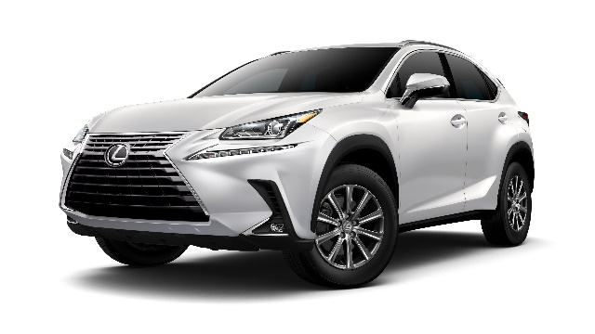

To Benefit the Students of
Holy Redeemer Catholic School

TICKETS ARE $100 EACH

No More Than a 1,000 Tickets Will Be Sold
The winning ticket will be drawn on February 27, 2021

(please print)
Name _______________________________________________________________________________________
Address ____________________________________________________________________________________
City __________________________________________________State___________ Zip_________________
Phone _____________________________________________________________________________________
Email ______________________________________________________________________________________
I wish to purchase _____________ ticket(s) at $100 / ea = $________________________Total
Credit Card VISA/MC/AMEX/Discover #_________________________ Exp_________ Zip __________
Enclosed is my check payable to Holy Redeemer Catholic School Check # ______________________

Holy Redeemer Catholic School
Attn: Jennifer Leonard
3380 Old Alabama Road
Johns Creek, GA 30022
770-410-4056 EXT 216 * 770-410-1454 FAX

