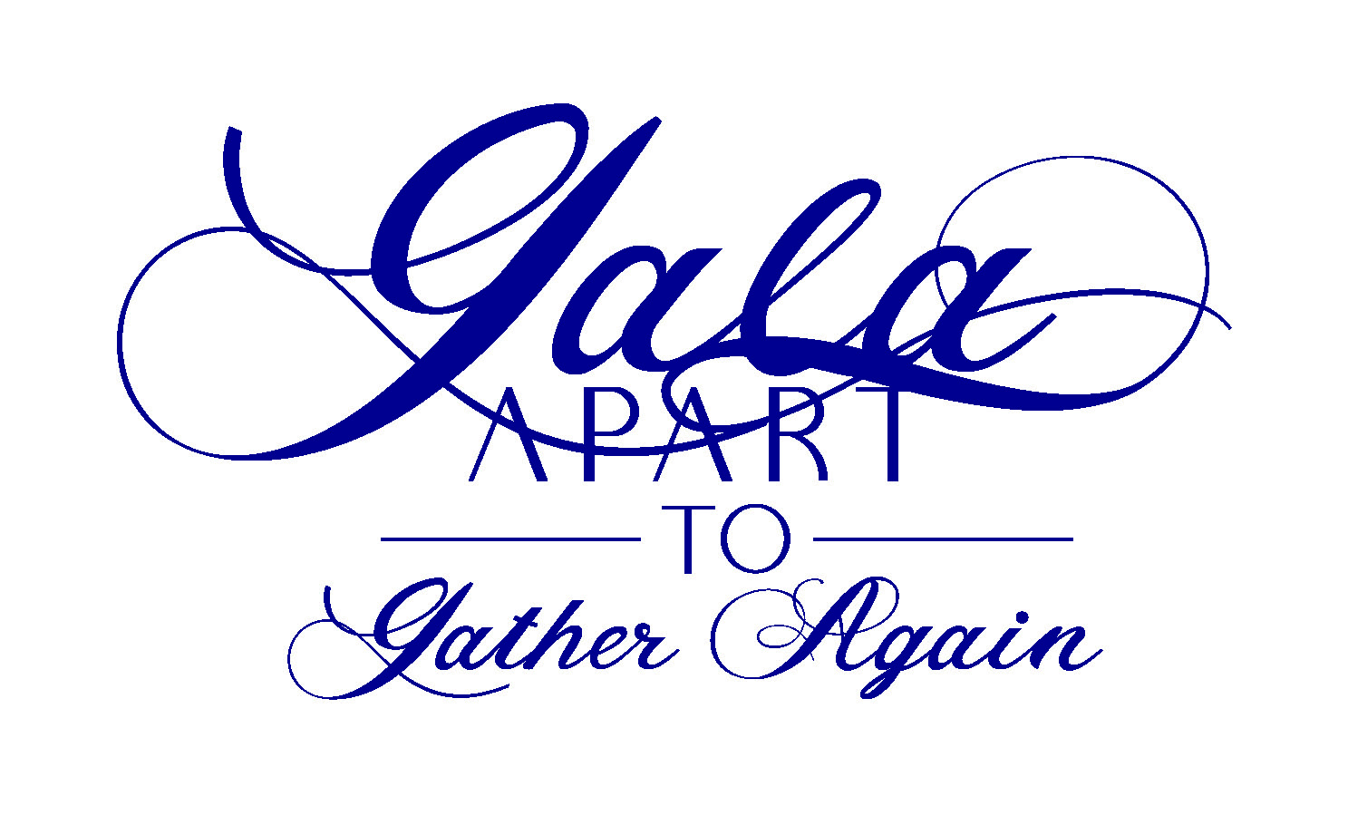
Premier
$3,000 Level (2) only 1 available. The remaining sponsorship is not available to an orthodontist as Dr. Mibab has purchased the first one. Remaining spot must be purchased by January 15, 2021
- Company logo on a Gala banner displayed in the front of school building. If the two spots are sold, the banner will be split with each logo.
- Recognition on the Gala website and mobile bidding device as Premier Gala Sponsor.
- Acknowledgement of sponsorship support during our February 2/27/21 event.
- 1 year social media advertising on all HR social media platforms.
- Charcuterie Board for 4 people plus dessert.
- Special access the night of the Gala to a video on how to prepare a Charcuterie board by owner of Village Pizza.
- 2 bottles of wine your choice from a list provided (white, red, rose)
Partner
$1,000 Level (unlimited)
- Printed recognition as Gala sponsor poster.
- Recognition on the Gala website and mobile bidding devices.
- Charcuterie Board for 2 people.
- Special access the night of the Gala to a video on how to prepare a Charcuterie board by owner of Village Pizza.
- A bottle of wine your choice from a list provided (white, red, rose)
Supporter
$500 Level (unlimited)
- Gala website recognition.
- $25 gift certificate to Village Pizza (to be used the night of the Gala)

